Policy Project - The Need for Interoperable EMR Systems in the US Healthcare System
HCA 448: Health Care Analysis and Evaluation - Dr. Ellis-Griffith
Western Kentucky University

I: Assessment (15 Points)

Patients are experiencing limited access to healthcare due to the out-of-pocket costs they have to face. Along with the limitations to access, the costs of medicine are becoming impossible for patients to overcome. Health insurance coverages and high deductibles lead the patients to a breaking point, resulting in the decisions to not see their providers. If patients are scared to see their providers, the issues they have to face becomes more than just the money they have to pay. Doctors are scared to get sued for their services so they are requesting unnecessary tests being done to these patients who are already worried about the cost of the visit alone. America’s health system is falling in the rankings because of the out-of-pocket costs and the high deductibles patients have to pay just to be seen by their doctor.

II: Policy Development (35 Points per Individual)
There is a lack of interoperability in electronic medical record (EMR) keeping systems in the United States health care system. Although technology has become a big part in the daily life of most people, the health care industry has been slow to adapt to such advancements. Through different studies it has been found that health care facilities that implement a basic electronic medical record (EMR) keeping system have a shorter length of stay in the facility and less rework being done; which ultimately results in lower cost to the organization. In addition to this, facilities that have implemented an EMR system reported an eighteen percent decrease in 30-day mortality rate (Lee, Kuo, Goodwin, 2013). With the use of EMRs, morbidity and comorbidity are more easily made aware of and controlled; resulting in safer, quality care being provided to patients. Although the implementation of EMRs can be pricey, in the long run they lower costs, lower mortality rates, and provide better care to patients; which results in higher reimbursements. Considering these performance leaps, despite the interoperability of most EMR systems in use, finding a system that can interchange information among health care providers would prove even more beneficial for health care organizations.
Specific Problems, Solutions, and Cost
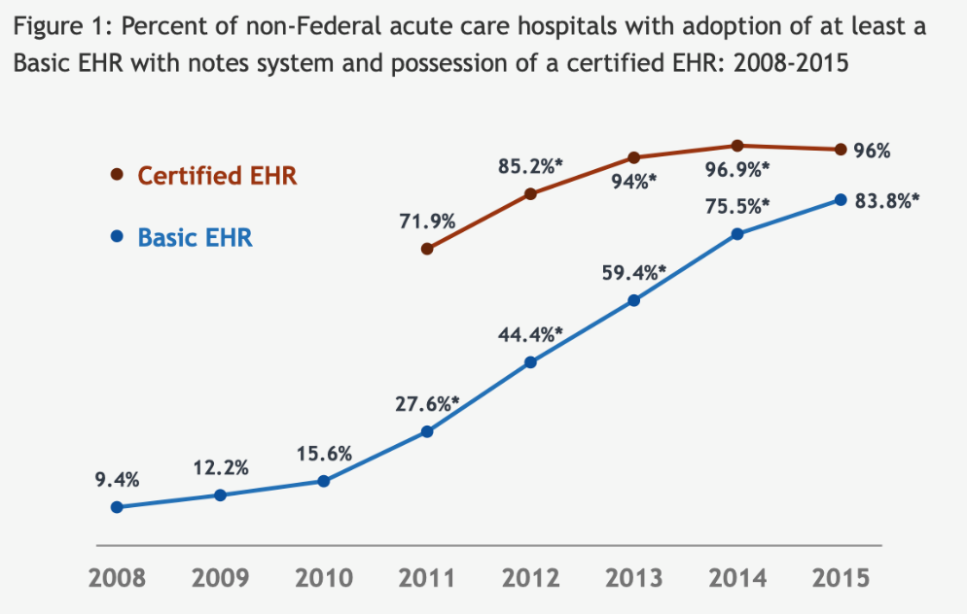
The passing of the Health Information Technology for Economic and Clinical Health (HITECH) Act was signed into law on February 17, 2009, and its purpose was to promote the adoption and meaningful use of health information technology (HHS Office, 2017). After its implementation, to receive the payment incentives and not be penalized, it was found that 96% of acute care hospitals had adopted some form of an accepted EMR system (Ray et al, 2019). As seen in Figure one, there has been a steady increase in the utilization of EMR systems (Adoption of EHR Systems among US Non-Federal Acute Care Hospitals, 2015). Although the substantial increase in electronic health record adoption across the country, this has not led to health data that is easily accessed. The systems deemed acceptable are not interoperable with one another, making patients frustrated and clinicians unable to make informed decisions. The HITECH Act pushed interoperability in a limited way, instead of creating a market demand for robust interoperability (Adler-Milstein, 2017). This difficulty in exchanging patient information has led to many specific problems in the health care system, but could seemingly be diminished through regulation of the standards set forth by the HITECH Act.
There is a lack of coordination in care among different health care providers that stems from not having an interoperable EMR system. To properly combat communication issues among health care providers that often result in poor quality care, the HITECH Act must be revised and an interoperable EMR system must be found. Considering that care providers are penalized if it is found they are providing less than quality care, despite the initial start-up cost being expensive, health care organizations would ultimately save and make more money with the implementation of a universally accepted EMR system. As previously stated, the HITECH Act was signed into law to promote the use of health information technology and the meaningful use of it. While this was its purpose, it did not ensure the interoperability of the accepted EMR systems. To start toward improving this issue, the act should reconsider all the approved EMR systems and make that selection narrower; which would in turn, make the scope of interoperability problems limited. Considering that the installation of an EMR system within a facility costs anywhere from $15,000-$70,000, there has to be adequate funding set aside to determine compatible systems. Also, considering that $27 million has been used for incentive purposes in the previously deemed acceptable EMR systems, taking $10 million, less than half of the incentives money, to properly find interoperable EMR systems is an adequate amount and will save the health care system in time, money, and resources in the long run (Halamka, 2010).
In continuance of the issue of coordination of care due to lack of interoperable EMR systems, a primary care physician has no way of knowing what medications that a specialized doctor has prescribed. For example, if the gynecologist put a patient on birth control and a few months later the patient becomes sick with strep throat, the physician has no way of knowing that the patient is on birth control and would not know that he/she needs to inform the patient that these medications counteract each other. The mixing of certain medications can result in adverse effects, some resulting in death. This lack of information sharing can result in poor quality care provided to patients. While many organizations conformed in order to avoid payment penalties, the lack of universal system standards made software used in one facility noninterpretable to another facility using different, but also accepted, software. Although changing record keeping systems can be untimely and financially burdening in the beginning, as previously stated, there is an estimated $27 billion being federally funded to organizations who are making meaningful use out of EMR systems and they are often times hard to meaningfully use; so that money could be better spent finding systems that actually work for those using them.
In recent studies, it is found that there is a high rate of health care providers experiencing burnout or dissatisfaction due to rework and waste occurring in their work. To reduce the amount of waste and better satisfy those providing care, a transferable EMR system that allows providers easier accessibility and recording of patient records is necessary. As previously stated, revising the HITECH Act by utilizing money that was previously used for payment incentives to find/create interoperable EMR systems would be a better use of funding. Do to the previous incentives under this act, the US health care system must retrofit interoperability, rather than making it a core value in our health care IT system (Adlet-Milstein, 2017). Payment incentives under this act should be substantially reduced during the time spent finding transferable EMR systems. As mentioned earlier, using $10 million of the $27 million being used for incentive purposes should be utilized in finding such systems; and although this will significantly reduce the amount of reimbursement for health care professionals temporarily, after a transferable EMR system is found, incentives can be reconsidered and put back in place to ensure health care facilities are utilizing the new found systems. With a transferable EMR system, physicians can better care for their patients with less rework and waste being produced in the process.
Care providers are often burdened with rework because of patient documentation error or inability to access patient records. A primary care physician could have all the reported information that occurred in their facility on the patient at hand, but because the patient has other specialized care providers (gynecologist, gastrologist, cardiologist, etc.) he/she is still missing vital information about the patient. Being that the primary care physician is using all that he/she has, he/she and employees working with him/her could become dissatisfied with the inability to properly treat the patients. By finding compatible/transferable systems, all of a patients care providers can have access to the needed patient information. This would, in turn, reduce the errors occurring in the distribution of care that are due to lack of attainable information and lower the amount of rework being done by care givers in the documentation process. Although pricing for the finding/creation of interoperable EMR systems seems high, suggested to be $10 million, using the funding from payment incentives will essentially not cost the health care system any more money; just utilize it in a different, more beneficial way.
Interest Groups
The United States health care system lacks interoperable EMR systems that challenge the quality of care provided to patients because of the lack of coordinated care and also contributes to the amount of rework, waste, and burnout in the health care industry. Although revising the HITECH Act in the previously stated ways would help interoperability of the EMR systems in use and ultimately help improve the ability to provide quality care to patients, it goes against the traditional US commitment to market-based approaches (Adlet-Milstein, 2017). With that being said, competitive health care facilities, such as hospitals, private practicing physicians, and other competing entities would be highly against the interoperability of EMR systems. By making records transferable, these competing facilities would be allowing their patients to seek care elsewhere, in turn, losing that provider and/or organization money. Specifically, the Hospital Cooperation of America (HCA) facilities would be against this interoperability transformation because they have facilities such as hospitals, urgent cares, and primary care physicians that could seemingly handle all of the care needed by the patient. HCA was one of the first hospital management companies in the United States, and now is one of the leading providers of health care services in the nation (Our History, 2019). This for-profit organization makes its monetary benefits through extreme competition with other providers located in their area and compliance with nationally set policies and standards; so as noted earlier, allowing their patient records to be easily transferred to a competitor will be seen as a market disadvantage and will likely be fought by this organization.
Despite the resistance from the big market competitors in health care, American Medical Association (AMA) is an interest group that is highly recognized and highly for the interoperability of EMR systems in the health care system. The AMA is the physicians powerful ally in patient care; the AMA represents physicians with a unified voice to all key players in health care, so having their support is going to be pivotal in making the needed changes to currently used policies regarding EMR systems in the US health care system. After the passing of the HITECH Act that caused EMRs mass implementation, it was determined that the currently used systems lacked usability, resulting in them being extremely hard to use when comparing them to other technologies (Harris, 2019). This lack of usability made the coordination of care nearly impossible for health care providers and also added mounds of rework and waste to their daily tasks. Considering that the technology advancement acts were put in place to improve communication and coordination of care among health care providers, this lack of uniformity is unacceptable and has actually worsened the ability to provide quality care to patients. While single physicians are likely opposed to anymore tampering with their record keeping system, the AMA adamantly supports the needed revisions to ensure that the new generation of EMR systems are designed to prioritize time with patients and making technology as asset not a burden (Harris, 2019). In figure two, the rate of interoperability/usability is compared the average burnout rate of differently specialized care providers that are a part of the AMA (Melnick et al, 2019). AMA research has shown that the high volume of data entry tasks associated with EMRs are among the major factors that drive physician dissatisfaction, attrition, and depression; not to mention the high burn out rates (Melnick et al., 2019). Having the AMAs support on making this change is essential, considering the physicians they represent are the individuals utilizing the systems.
Figure 2
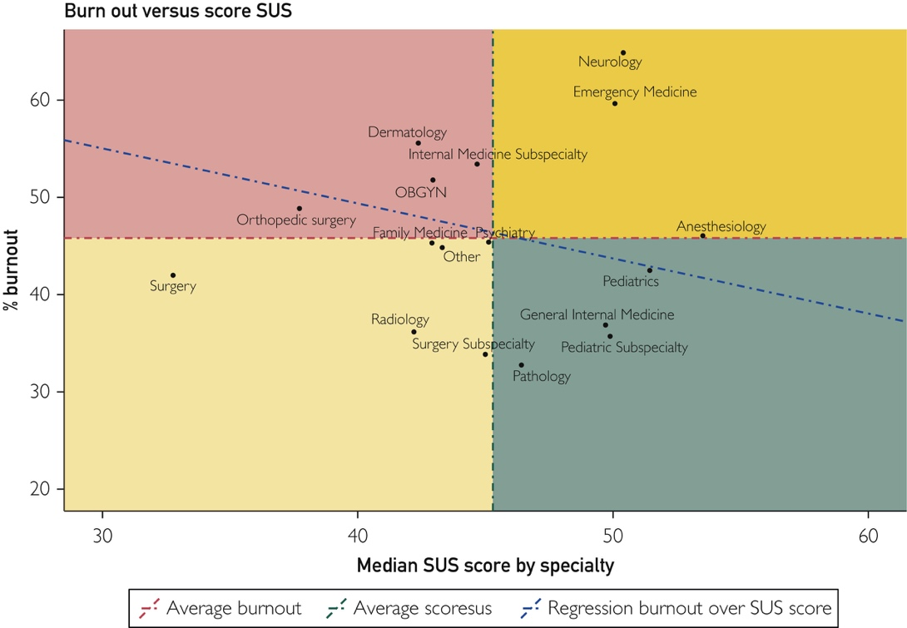

Assurance
According to the US National Library of Medicine and National Institutes of Health, in order to reduce medical errors, provide effective methods of communication and sharing information among clinicians, and better manage patient medical records, the US health care system needs to embrace the advancements in information technology (National Academy of Engineering & Institute of Medicine Committee on Engineering and the Health Care System, 2005). In order to properly do this and combat the issue of the lack of inoperable EMR systems in the US health care system, there must be policy revisions and assurance mechanisms to ensure that changes are working as they were planned to. As stated in the New York Times, the US spends a tremendous amount of money on health care but very little of it goes toward learning which health policies work and which do not; less than 0.1% of total spending is devoted to evaluating these policies (Frakt, 2019). Earlier this year, legislation signed into law the Foundations for Evidence Based Policymaking Act of 2018, also known as the Evidence Act. This act will assist in the policy revisions previously recommended, help usher a cultural shift toward evidence based policy, and shine new light on many currently used policies challenges (Hahn, 2019). From its broad support from Congress, it is suggested that many legislators are beginning to see the value of making sure the policies being put in place and funded by them are delivering on their promises (Hahn, 2019). With that being said, this act will assist in getting the revisions being made to the HITECH Act passed and funded.
Short term (1-5 years), there should be constant revision and studying of issues of operability in the currently defined acceptable EMR systems. Considering the high rates of dissatisfaction from patients and providers due to the difficulties in coordinated care and the rework/waste that is produced in the process, finding transferable systems faster will lead to quicker monetary relief and better quality care being provided. Once new, transferable systems are found/created, the HITECH Act will have a redefined selection of acceptable EMR systems. To properly ensure these newly acceptable systems are interoperable, there should be a fraction of the money used in finding them, dedicated to continuous revision of them. No system will ever be perfect, but continuous monitoring and editing will assist in them being utilized in the best way. By allocating at least $2 million a year to EMR system continuous improvement techniques after the new systems have been found and deemed acceptable, the long term objective (5 years) is to improve the satisfaction of patients and providers in relation to the coordination of care and reduce the rate of health care provider burnout due to rework and waste. After the first five years of the newly found EMR systems implementation, data relating to coordination of care and rework/waste will be analyzed to see if there has been improvements in either of the problem areas. Considering they will be constantly reviewed, there should be a significant amount of increased satisfaction and decreased rework/waste in the patient documentation process.

References
Adler-Milstein, J. (2017, July 18). Moving Past the EMR Interoperability Blame Game .
Retrieved from https://catalyst.nejm.org/doi/full/10.1056/CAT.17.0448.
Adoption of EHR Systems among U.S. Non-Federal Acute Care Hospitals:
2008-2015. (2015). Retrieved from https://dashboard.healthit.gov/evaluations/data-briefs/non-federal-acute-care-hospital-ehr-adoption-2008-2015.php.
Frakt, A. (2019, September 9). Which Health Policies Actually Work? We Rarely Find Out.
Retrieved from https://www.nytimes.com/2019/09/09/upshot/which-health-policies-actually-work-we-rarely-find-out.html.
Hahn, R. (2019, May 10). Building upon foundations for evidence-based policy. Retrieved from
https://science.sciencemag.org/content/364/6440/534.
Halamka, J. (2010, September 28). Electronic Health Record Standards. Retrieved from
https://www.healthaffairs.org/do/10.1377/hpb20100928.658660/full/.
Harris, P. A. (2019, November 14). New research intensifies AMA's call for improved EHR
usability. Retrieved from https://www.ama-assn.org/press-center/ama-statements/new-research-intensifies-ama-s-call-improved-ehr-usability.
HHS Office of the Secretary,Office for Civil Rights. (2017, June 16). HITECH Act Enforcement
Interim Final Rule. Retrieved from https://www.hhs.gov/hipaa/for-professionals/special-topics/hitech-act-enforcement-interim-final-rule/index.html.
Lee, J., Kuo, Y.-F., & Goodwin, J. S. (2013, February 1). The effect of electronic medical record
adoption on outcomes in US hospitals. Retrieved from https://www.ncbi.nlm.nih.gov/pmc/articles/PMC3568047/.
Melnick, E. R., Dyrbye, L. N., Sinsky, C. A., Trockel, M., West, C. P., Nedelec, L., … Shanafelt,
T. (2019, September 24). The Association Between Perceived Electronic Health Record Usability and Professional Burnout Among US Physicians. Retrieved from https://www.mayoclinicproceedings.org/article/S0025-6196(19)30836-5/fulltext.
National Academy of Engineering (US) and Institute of Medicine (US)Committee on
Engineering and the Health Care System. (2005). Information and Communications Systems: The Backbone of the Health Care Delivery System. Retrieved from https://www.ncbi.nlm.nih.gov/books/NBK22862/.
Our History. (2019). Retrieved from https://hcahealthcare.com/about/our-history.dot.
Ray, J. M., Ratwani, R. M., Sinsky, C. A., Friedberg, M. W., Frankel, R. M., Powsner, S. M., …
Melnick, E. R. (2019, July 2). Six habits of highly successful health information technology: powerful strategies for design and implementation. Retrieved from https://academic.oup.com/jamia/article-abstract/26/10/1109/5527253?redirectedFrom=fulltext.

